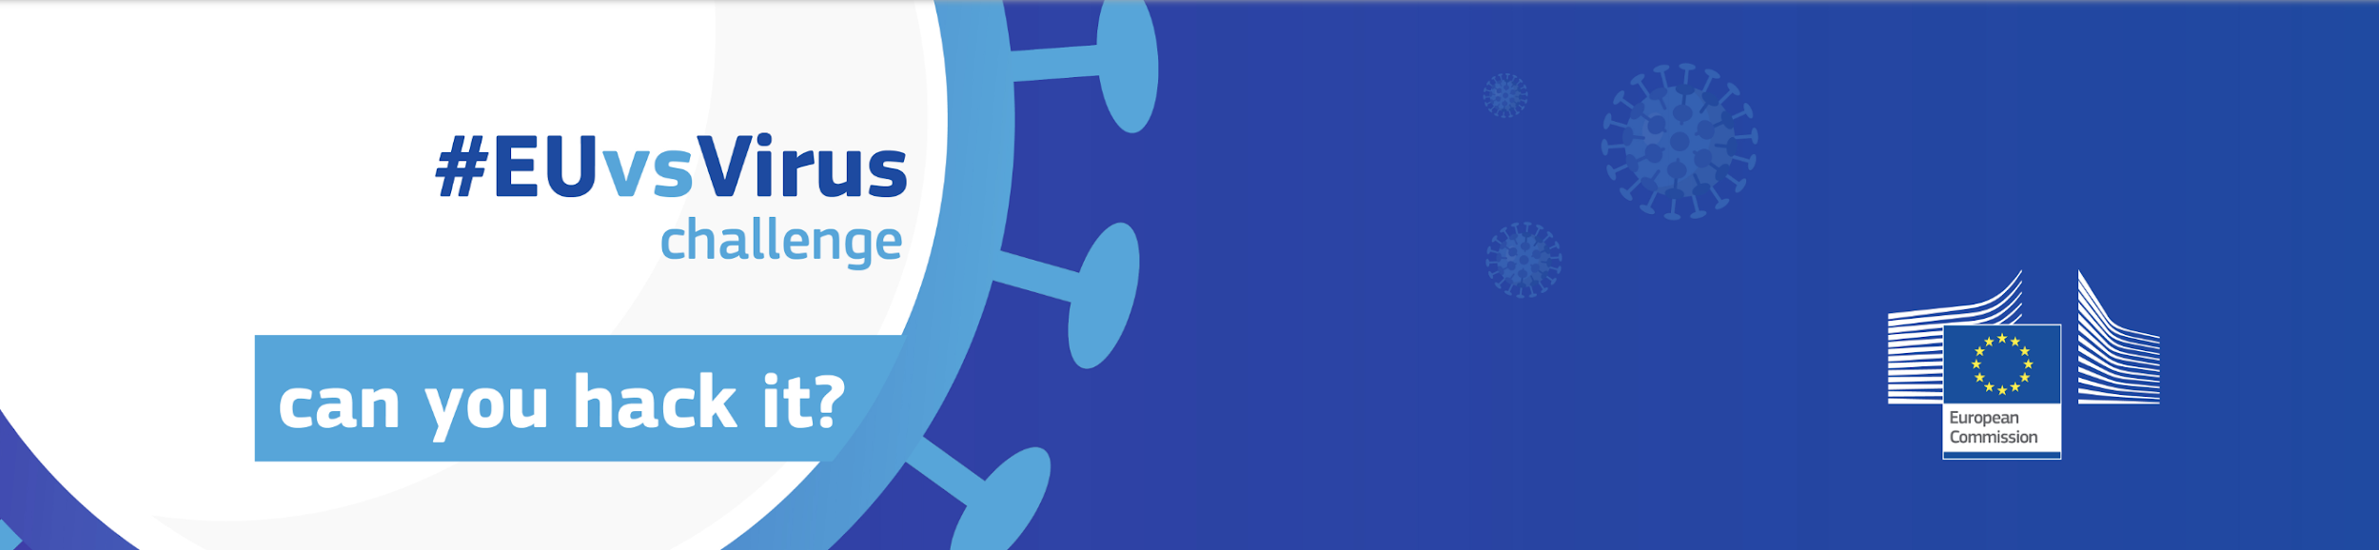

Marketing Information Kit

Table of content:
Social Media links 1
Hashtags 1
What to do on Social Media 1
Press releases 3
Marketing materials 3
Timeline and content suggestions 4

Social Media links:
- Facebook
- Linkedin
- Facebook event
- Twitter
- Instagram
- Youtube
- DevPost

What to do on Social Media
Here are some suggestions of how you can do that:

- Post to your social media channels
- Invite your friends to the Facebook Event
- Share #EUvsVirus content posted on EU Commission platforms
- Message relevant Facebook pages and ask to share the event
- Invite friends to the Facebook event
- Post to relevant Facebook and LinkedIn groups and Slack workspaces you are a member of
- Reach out to relevant key players (incubators, accelerators, VC funds, universities) on your ecosystem and ask them to join and also share the event with their networks
- follow the European Commission social media:
  - Twitter
  - Facebook
  - LinkedIn

Hashtags to use and share:
#EUvsVirus (always use this one)
Other hashtags: #HacktheCrisis #EUSolidarity #StrongerTogether #TogetherWeCan

See all content posted with the hashtag (we recommend you check these often and share/like/comment on posts):
- On Twitter
- On LinkedIn
- On Facebook

#time-to-share:
Often, we all are too busy with work and forget to share it with our friends. So, once in a while, before and during the Hackathon, we will announce ‘it’s time-to-share’ on Slack to invite everyone to join our social media efforts and share, like, interact with posts using the official hashtag. A fun way to boost the hashtag use and get it on trending topics (hopefully) across Europe.

Press releases:
The press releases issued by the EU commission are available at the press page of the EUvsVirus website. We will also post any new release to the Slack channel as soon as it is issued.

Marketing materials

Video:
(Files to download and use on your social media posts)
Mp4 High Quality (195MB) : https://we.tl/t-Hps8QoWFps
Mp4 YouTube (158MB) : https://we.tl/t-pbJTDmIqtS
Mp4 Social media (120MB) : https://we.tl/t-gwaI4OOa17
YouTube link: https://youtu.be/gkC6YEinomA

Visuals:
All visuals can be found at here
(we’ll add more visuals as they are produced)

All new images need to include the following: “Organized by the European Commission, managed by the community”

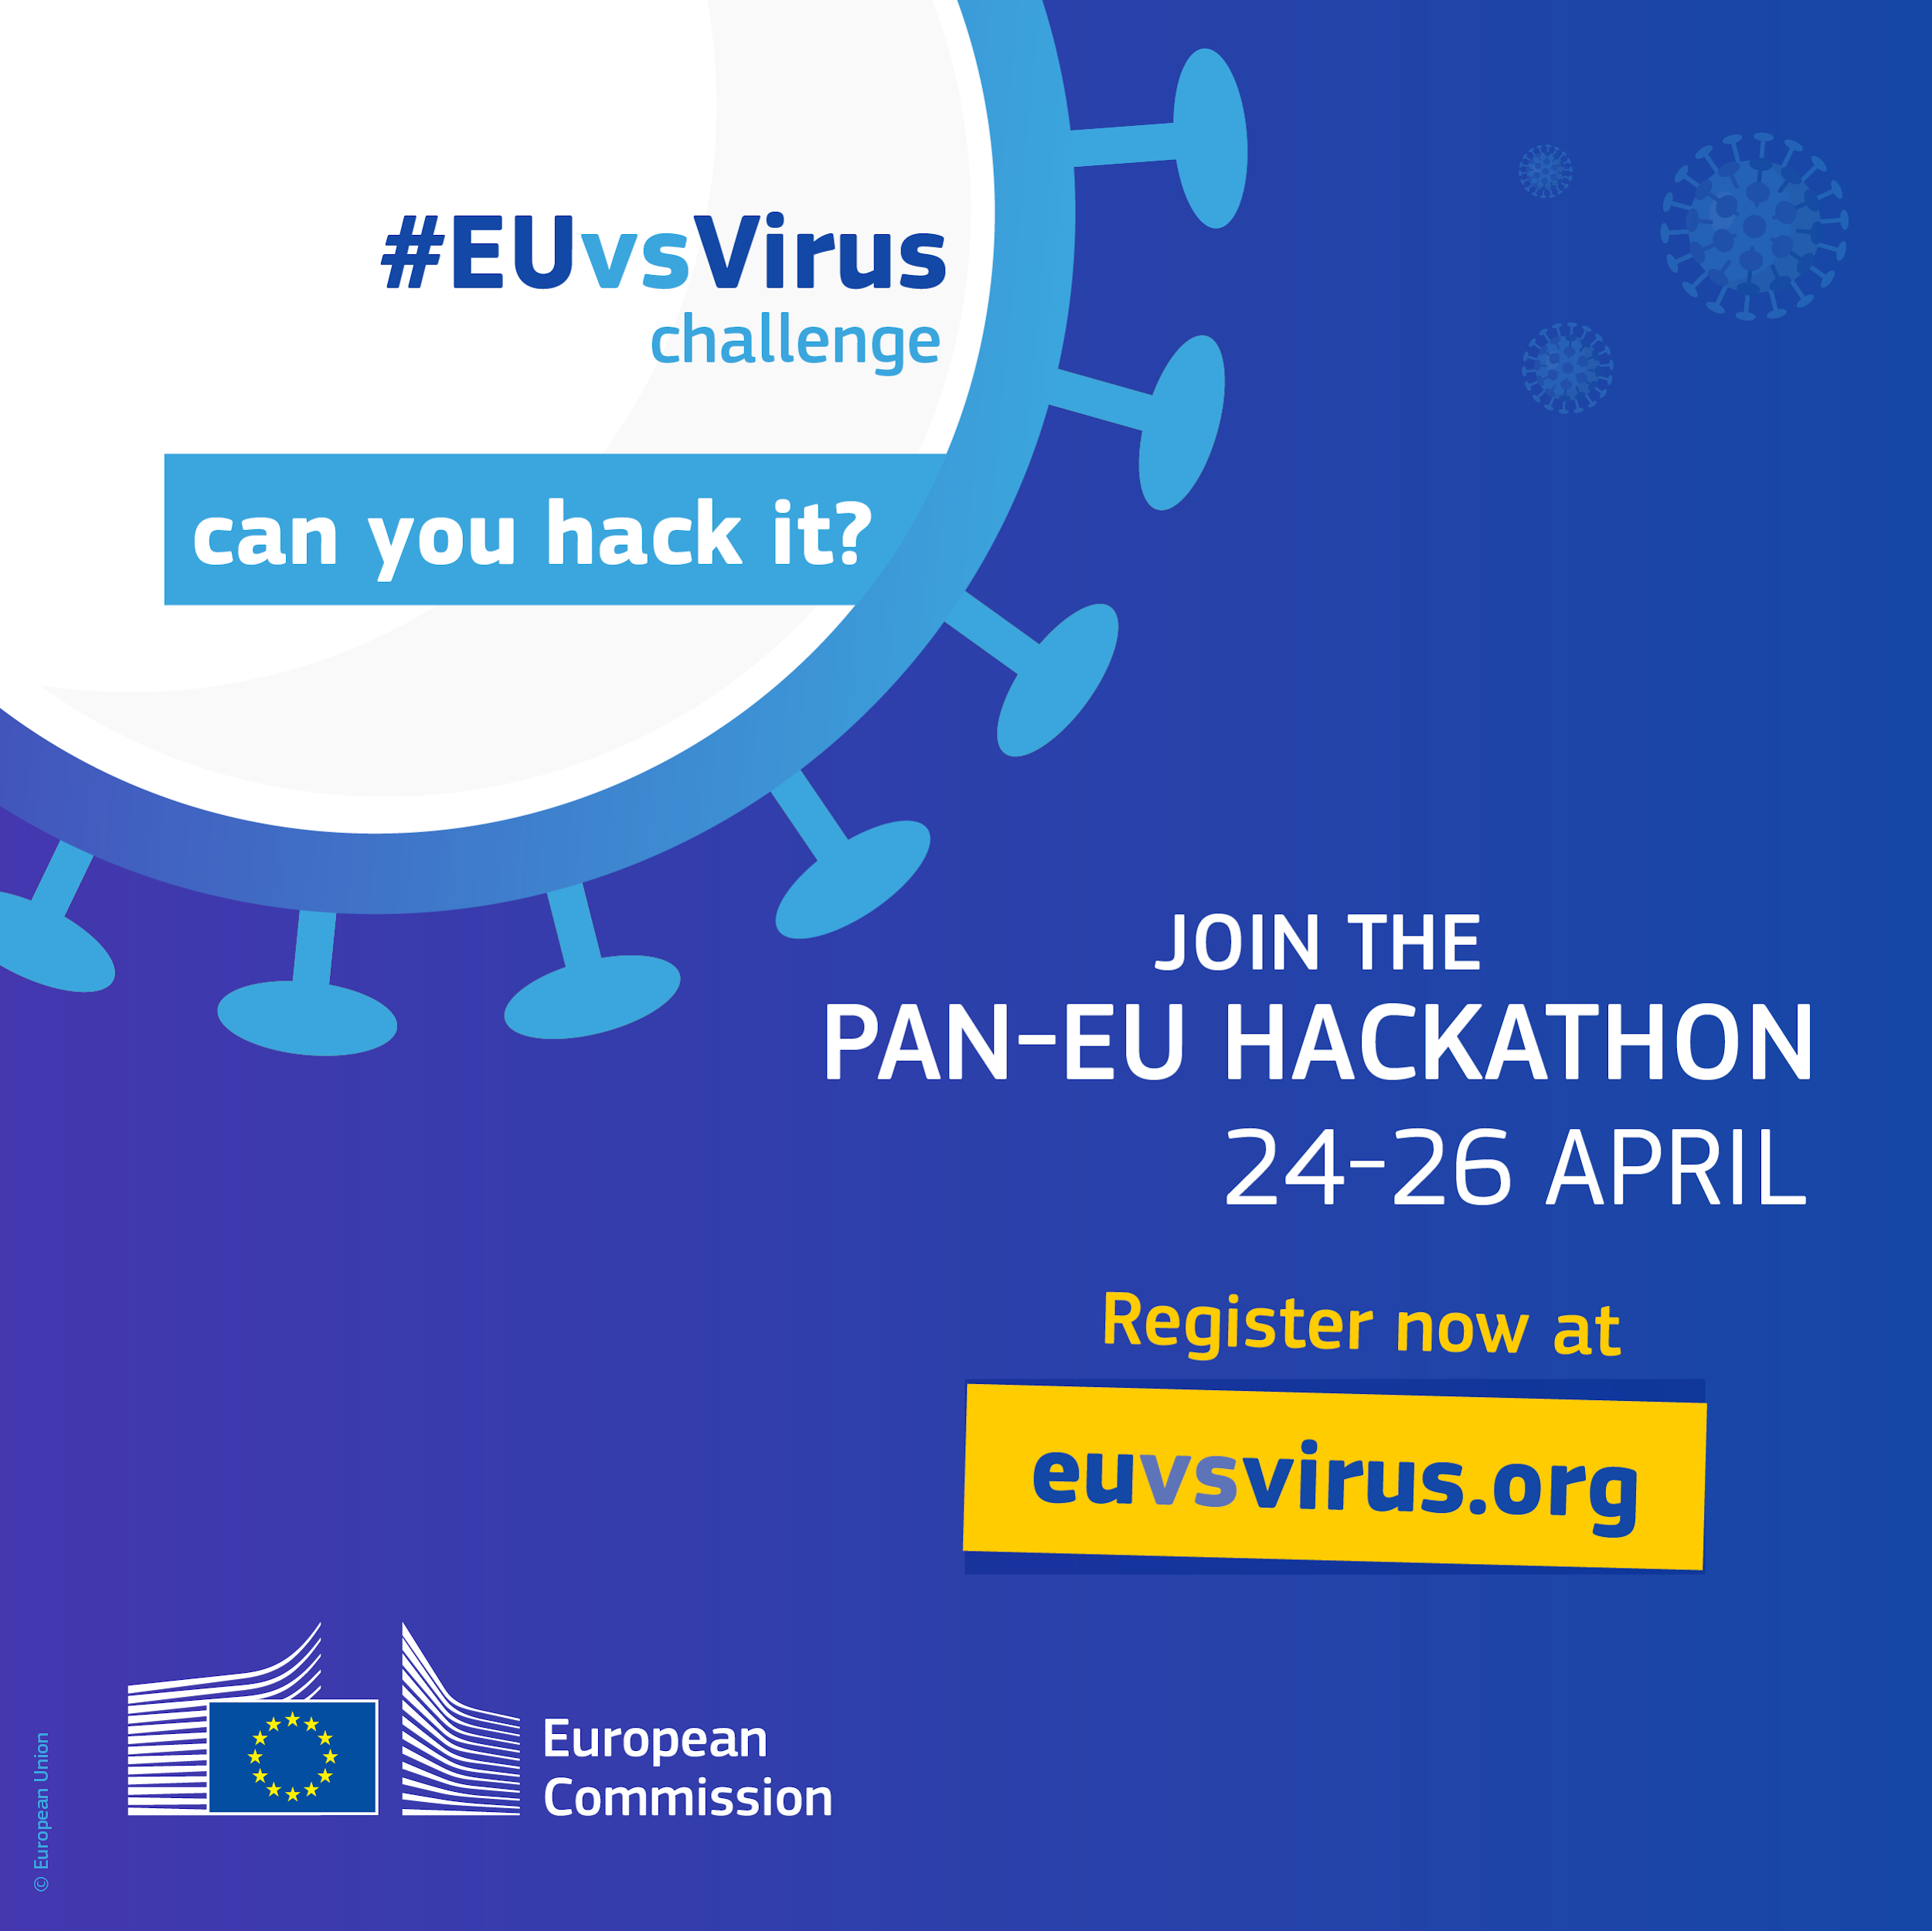
Content suggestions

Before event:

14/04 - Official launch - challenges defined and registrations open
From this day until registrations close, it is very important we share and reach out as much as we can to attract participants and get press coverage. Here’s some content ideas:
Post to social media:
Share content from EU Commission channels, create your own posts or use one of the following suggestions:
Suggestion 1:
“Join #EUvsVirus and participate in the fight against COVID-19!

Supported by the EU Commission, EUvsVirus is an online hackathon organized by the digital ecosystem actors from all over Europe and happening between 🗓️April 24-26.

The participants are invited to develop innovative solutions to COVID-19 related challenges in 48h.

It is a call to action to each and everyone to demonstrate unity for the common good across borders and generations. Let’s digitally open EU-borders in the times of pandemic crisis!

https://youtu.be/gkC6YEinomA

Join here: https://euvsvirus.org/”

Suggestion 2:
“We are #InthisTogether, let's #HackforEurope! The pan-European #EUvsVirus 🇪🇺Hackathon will take place on 🗓️24, 25 and 26 April, and we invite you to join. Let’s show our #EUSolidarity! Challenge areas are:
🌱health and life
💼business continuity
👨‍💻remote working and education
🤝social & political cohesion
💳digital finance
✅other challenges
https://youtu.be/gkC6YEinomA

Register now here: https://euvsvirus.org/”

Suggestion 3:
“Can you Hack it? Put your skills to good use in this #EUvsVirus 🇪🇺 Hackathon on 🗓️24, 25 and 26 April. Find out more about the challenges to be hacked and register today:

https://youtu.be/gkC6YEinomA

To register visit https://euvsvirus.org/”

Suggestion 4:
The European Commission - in close collaboration with EU member states 🇪🇺 – will host a pan-European hackathon to connect civil society, innovators, partners and buyers across Europe to develop innovative solutions to coronavirus. The #EUvsVirus Hackathon will take place on 🗓️24, 25 and 26 April and address imminent coronavirus challenges areas of:
🌱health and life
💼business continuity
👨‍💻remote working and education
🤝social & political cohesion
💳digital finance
✅other challenges
The aim is to quickly develop and deploy solutions across the EU Single Market. Find out more about the challenges to be hacked and register today!
https://youtu.be/gkC6YEinomA

To register visit https://euvsvirus.org/”

Message to relevant Facebook and LinkedIn pages:
Hi,
Between April 24-26, the EU Commission will host EUvsVirus hackathon, and I am reaching out to ask you to help us, by inviting your followers to join and share it with people who would like to join. We would really appreciate if you could share the event on your page. Here’s an idea of what you can share:

“Join #EUvsVirus and participate in the fight against COVID-19!

Supported by the EU Commission, EUvsVirus is an online hackathon organized by the digital ecosystem actors from all over Europe and happening between April 24-26.

The participants are invited to develop innovative solutions to COVID-19 related challenges in 48h.

It is a call to action to each and everyone to demonstrate unity for the common good across borders and generations. Let’s digitally open EU-borders in the times of pandemic crisis!

https://youtu.be/gkC6YEinomA

Join here: https://euvsvirus.org/”

Post to groups (remember to edit the links as you see fit for the group/organization/person you are reaching out to):
Dear Members,
I hope you are all healthy and safe. Between April 24-26, the EU Commission will host EUvsVirus.org hackathon, and I would like to invite you all to join and share it with people who would like to join!

The EUvsVirus is an online European-wide hackathon organized by the most plugged in and nationally connected digital ecosystem actors from all over Europe. We are aiming to mobilize 60,000 people to create innovative solutions to COVID-19 related challenges.

It is a call to action to each and everyone to participate in the fight against COVID-19: demonstrate unity for the common good across borders and generations. Let’s digitally open EU-borders in the times of pandemic crisis!

How can you join?
🚀Register as participant: https://euvsvirus.org/
🧠Register as a mentor: https://euvsvirus.typeform.com/to/V5xqpy
🦸Register as a team-lead (organisation and coordination of the teams during the hackathon): https://euvsvirus.typeform.com/to/Fm602V
Join as a corporate: https://ec.europa.eu/eusurvey/runner/EUvsVirus_Corporate
Join as a university: https://ec.europa.eu/eusurvey/runner/EUvsVirus_Universities
Join as an NGO: https://ec.europa.eu/eusurvey/runner/EUvsVirus_Foundations
Join as a public authority: https://ec.europa.eu/eusurvey/runner/EUvsVirus_Foundations
Join as private partner: https://ec.europa.eu/eusurvey/runner/EUvsVirus_Foundations

Let’s solve the crisis all together!

LinkedIn Message or e-mail to key players (remember to edit the links as you see fit for the organization/person you are reaching out to):
Subject: EUvsVirus - a pan-european hackathon against COVID-19

Dear XXX,
We hope you are well.
Between April 24-26, the EU Commission will host EUvsVirus hackathon, an online European-wide hackathon organized by the most plugged in and nationally connected digital ecosystem actors from all over Europe, aiming to mobilize 60,000 people to create innovative solutions to challenges related to COVID-19.

We would like to ensure that (company name, country or industry) community is part of this event and so we are looking for your support as an ecosystem key player to help us spread the word. Let’s digitally open EU-borders in the times of pandemic crisis!

If you’re up to joining us, here’s a few ways you can do it:
🚀Register as participant: https://euvsvirus.org/
🧠Register as a mentor: https://euvsvirus.typeform.com/to/V5xqpy
🦸Register as a team-lead (organisation and coordination of the teams during the hackathon): https://euvsvirus.typeform.com/to/Fm602V
Join as a corporate: https://ec.europa.eu/eusurvey/runner/EUvsVirus_Corporate
Join as a university: https://ec.europa.eu/eusurvey/runner/EUvsVirus_Universities
Join as an NGO: https://ec.europa.eu/eusurvey/runner/EUvsVirus_Foundations
Join as a public authority: https://ec.europa.eu/eusurvey/runner/EUvsVirus_Foundations
Join as private partner: https://ec.europa.eu/eusurvey/runner/EUvsVirus_Foundations

You can can also share the following social media post with your community:

“Can you Hack it? Put your skills to good use in this #EUvsVirus 🇪🇺Hackathon on 24, 25 and 26 April. Find out more about the challenges to be hacked and register today:

https://youtu.be/gkC6YEinomA

To register visit https://euvsvirus.org/”

And please don’t forget to use our hashtag #EUvsVirus so we can like your posts!

Thank you,

Kindest regards,

XXXXX

14/04 - Press release by EU Commission available
You can translate the press releases to your own language if you wish to in order to relay to the relevant media

19/04 - Registrations close
Post Calls-to-Action on your channels and reach to your communities to attract participants
Post to social media:
Today is the last day ⏳to register to take part on EUvsVirus 🇪🇺hackathon - we are counting on you to help develop innovative solutions to overcome coronavirus-related challenges.

We are welcoming developers, designers, creatives and problem solvers with expertise in healthcare, business, sociology, education etc. Is that you? Register now!

To register visit https://euvsvirus.org/”

During event:

24/04, 5pm - Opening Ceremony
Social Media post idea:
EUvsVirus 🇪🇺hackathon is about to start, teams from all over the continent have joined together to tackle challenges related to COVID-19. Over the next 48h they will be developing ideas around health & life, business continuity, social & political cohesion, remote working & education, digital finance and more.

Follow the opening ceremony today, at 5pm (CET) live at (link).

25/04 - Teams working
Social Media post ideas:
- Share team meeting screengrabs
- How many teams or participants from your country?
- Along the lines of “We are now nearly 24h in the EUvsVirus Hackathon. Our brave participants are hacking away and some incredible solutions are being developed. Here’s some photos…”

26/04 - Last day/closing ceremony
Social Media post idea:
Only a few hours until our brave #EUvsVirus hackers submit their projects. We can’t wait to see all the groundbreaking ideas coming through.

And if you are curious too, make sure to check the closing ceremony where the winners will be announced.

Follow the closing ceremony today, at 5pm (CET) live at (link).

After event:
Write blogs, articles, social media posts about the hack. Most importantly, help the teams that are pushing forward to get their word out.
Social Media post ideas:
- Results
- Overall numbers: participants, countries, projects

