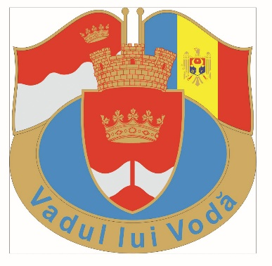

Request for a partner in the Czech Republic

Name of community: Vadul lui Voda
Country: Republic of Moldova

Population: 5200

Contacts:
Title Mayor
Name Iurie Onofriiciuc
Address 60 Stefan cel Mare Str.,
Vadul lui Voda
Postcode 2046
City Chisinau
Country Moldova
Phone +373 22 416 138
Fax +373 22 416 283
E-mail aplvadulluivoda@gmail.com

Historical background

For the first time Vadul lui Voda was mentioned in chronicles in 1432. It was founded by Stefan cel Mare, one of the greatest Moldovan princes. After one of his glorious battles he rested in a picturesque place which he liked much. In 1855 a museum was opened in Vadul lui Voda. The museum contained a rich collection of antique artifacts from Egypt, Greece, Italy. Later the museum was moved to Chisinau, the capital of the country.
The navigation of the river Nistru started in 1868. It influenced strongly on the development of trade and commerce.
The recreational value of the town was taken into consideration after 1950. It was given a special status on basis of air and water analyses made by special laboratories. The territory was defined as a terapeutical zone where a number of sanatoriums and camps were build. In 1960 a large park (524 ha) was planted along the bank of the river.
Annually more than 5000 people get treatment in 2 sanatoriums and more than 10000 people rest every weekend on the beaches of the river.

Main economic activities
Tourism
The resort area of the town occupies 584 ha. It is covered with dense forest and parks. There are more than 100 tourist camps, 9 summer camps for children and two sanatoriums on the territory of the town. There is a comfortable beach on the bank of the river Nistru. Next to the beach there is a number of snack-bars and small restaurants and entertainment units.
There are two stadiums in the town, one of them belongs to Moldovan Football Federation, and another one is in public property.
There is also an airdrome for sky-diving and hang-gliding.
The town is situated not far (25 km) from the capital of Moldova, Chisinau. Chisinau International Airport is located 40 km distance from the town. An international route (to Odessa, Ukraine) passes next to Vadul lui Voda.

Social life of the town

There is a primary school and a Lyceum in the town. More than 500 children go to these schools. Along with kindergarten, primary school and Lyceum the youth of the town can spend their leisure time and improve their talents and abilities in the Centre of Extracurricular Activities, the Musical school, the Sport school, and the Community Centre. Annually an international camp is organized where local children get acquainted with their peers from twinning towns from Romania, Poland, Ukraine, Lithuania and Bulgaria. Local children also visited Poland, Germany, Romania and Bulgaria in 2008-2018 years.

Our town is popular on a local level due to several cultural activities, such as: annual musical festivals, concerts of pop-singers held on the beach of the town, folk concerts, etc. Different folk concerts are organized in the town and they are really impressive and interesting as the population of the town is multinational and represented by Moldovans, Romanians, Russians, Ukrainians, Gagauzes, Bulgarians, etc.

There are two stadiums (one private and one public), a sport school for children (on the territory of the school there is a small football stadium with artificial turf), and a small power-lifting club.
Annually a wide range of different sport activities are held in the town. Among them: annual football, beach football, boxing, power-lifting championships for youth, competitions for inhabitants of the town organized during special events (Town’s Day in November, Mothers’ Day in March, etc.)

Possible fields of cooperation:

In order to find an appropriate partner in the Czech Republic we would like to address small towns with population up to 10 000 people, preferably with tourism of any kind (rural, medical, sport, etc.) as one of the main economic branches of the town. The experience of other tourist towns is very important for our developing infrastructure.

Here is a list of existing partners of Vadul lui Voda town:

- Romania: Baile Herculane, Pucioasa
- Ukraine: Yaremche
- Lithuania: Janova
- Italy: Morimondo
- Poland: Slawa
- Bulgaria: Malko Tirnova

