

**Invitation**

The Hungarian Association of Local Governments (MÖSZ) is holding the X. World Meeting of the Hungarian Mayors at the **Royal Palace of Gödöllő in Hungary** on **28 – 29 June 2014.**

Venue: **Royal Palace of Gödöllő, Riding Hall**

<http://www.kiralyikastely.hu/main_page>

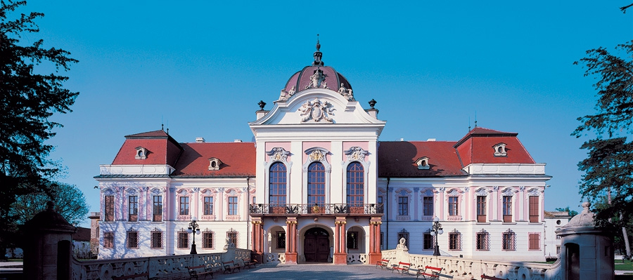

I would be honoured to invite you to our event.

This year is a special opportunity for us with V4 local governments’ associations and local governments to celebrate together the 10th anniversary joining to the European Union and the 25th anniversary of the democratic changes and impacts of the local reforms.

In the frame of the relevant Word Meeting, we are holding a Conference on “**Meeting of the V4 Associations of Local Governments and V4 twinning municipalities”** on 28 June with aim to discuss together with the heads and representatives of the Visegrad local governments associations and the V4 municipalities, mayors, ambassadors, home and cross-border mayors and communities, the Hungarian Ministry of Foreign Affairs the Visegrad best practices, tasks, co-operation and lobby issues of the LRAs, EU Funds and common cooperation possibilities in the next EU budget period, impact of the local reforms in the last 25 years etc.

**Accommodation**

**Self cost accommodation** is providedin the Szent István University Residence (Hungarian home mayors/participants will be also here). Pictures and some details of the accommodation on the WEB: <http://sziekollegium.hu/en/>

Price of the rooms

Single room: 7.200 HUF/ room/ night - +300 HUF tourism tax/person/night

Double room: 9.600 HUF/room/night - +300 HUF tourism tax/person/night

Please, send your registration with accommodation request too **with your name, town, country, arrival and departure date** to **Ms. Hajnalka Szabó** **(**e-mail: [hajni.alex@gmail.com](mailto:hajni.alex@gmail.com)) **by 2 May 2014.**

Please, find enclosed the program draft and the registration form and my colleague, **Ms Hajnalka Szabó** remains fully at your disposal for further questions.

**dr. Hajnalka Szabó**

Tel: +36/28-529-140

Mobil: +36/30-2686105

E-mail: [hajni.alex@gmail.com](mailto:hajni.alex@gmail.com)

**Catering during the event for 2 days is provided for all participants by the MÖSZ - Hungarian Association of Local Governments.**

I am looking forward to welcome you in Gödöllő in summer.

Gödöllő, 31 March 2014.

Yours sincerely

Dr. Gémesi György

President