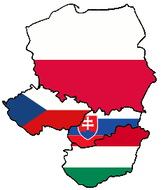
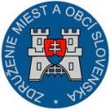
Application – Registration Form
Mayors’ tournament of the V4 countries
August 29th – 30th, 2013

List of the team members, country: _________________________ (max. players is 18, total members of the team is max. 22)
No. | Name and Surname | Date of birth ^{x} | Name of the city | Function/Position  (mayor ...) | Accomodation*  28.8./29.8. | Accomodation*  29.8./30.8.  28./29.8. | Accomodation**  30.8./31.8.  28./29.8.
1.
2.
3.
4.
5.
6.
7.
8.
9.
10.
11.
12.
13.
14.
15.
16.
17.
18.
19.
20.
21.
22.

x the age of the players: Vice Mayors may form max. 20% of the members of the team and cannot be younger than 40 years
*accommodation and other administrative costs: cost is 60 euros / person / day
** we assume that you will book standard accommodation min. for 28./29.6. and 29./30.6.2013 i.e. fee € 120
We ask you to pay the fee and send confirmation together with your application:
Bank: PRIMA banka Slovensko a.s. Account number: 1175981001 Bank Code: 5600
IBAN: SK67 5600 0000 0011 7598 1001 BIC bank code: KOMASK2X

Fully completed application form (with proof of payment of a fee) please send max. till 15.07.2013 to the e-mail zmo@zmo.sk and starosta@ruzindol.sk
Alternatively, a paper copy by mail: ZMO, región JE Jaslovské Bohunice, Trhová 2, 917 01 TRNAVA, Slovakia

