REQUEST FOR TWINNING

Name of Community: Romny City
Address: 2, Shevchenka bulvar, Romny city, Ukraine, 42000
Region: Romny Country: Ukraine
Contact person: Golovko Tetyana
Phone number: +3050 4006405 Fax: +30544821485
E-mail: romen@sm.ukrtel.net Website: www.romny.osp-ua.info
romny-invest@ukr.net

Population: 45,117 thousand inhabitants
Geographical Location and Characteristics:
Countries bordering with Ukraine: Poland, Byelorussia, Russia, Moldova, Roumania.
Romny city has a favourable geographic location: Kyiv – 270 km, Minsk – 495 km, Moscow – 571 km, Warsaw – 865 km, Instanbul – 1217 km, Prague – 1344 km, Berlin – 1383 km, Rome – 1876 km, Paris – 2225 km
The region has a railway communication with Dniepropetrovsk, Simferopol, Minsk, Moscow, Odesa, St. Petersburg. There are 31 routes in the city for passengers’ transportation.
The airports are in Sumy and Kyiv.
General Chacteristics of Community:
Area of Romny city – 2.9 thousand hectares.
The city is located in a forest-steppe area with a moderate climate. The average annual temperature of the air is 6.7. The average annual rainfall - 600 mm.
The soils are presented by black earth (chernozem) with a low or middle concentration of humus. It borders with Chernihiv and Poltava oblasts of Ukraine
Historical background (Brief note of any major historic events, buildings, monuments, famous people etc.):
➢ The first settlements appeared in Romny region 30-15 thousand years ago
➢ The first references to the lands of Romny region are in the Laurentian chronicle dating back to the year of 1096 B.C.
➢ It’s a homeland of the last ataman of Zaporijye Sich P. Kalnyshevsky
➢ Till the middle of the 19th century the city organised Illinsky fair which was number 2 in the Russian Empire by its importance
➢ Monuments of Scythian times
➢ A historic and cultural reserve “Posullia”
➢ Historic monuments (including the monument to T.G. Shevchenko – the first one in the world and the monument to the last ataman of Zaporije Sich Petro Kalnyshevsky)
➢ Numerous architectural monuments (among which there are Sviatodukhivsky Cathedral, Vassylivska and Voznesenska churches)
Principal Economic Activities (agriculture, industries, tourism etc.):
There are 13 industrial companies of different branches of economy operating in the city
Network of companies of the open joint-stock company “Ukrnafta” (Ukrainian oil company)
The scope of industrial goods sold per person in 2007 has increased by 3.1%
Structure of volume of main goods and services: Industry – 34.5%, Transport and communications – 13.1%, Education – 12.6%, Health care and social assistance – 17.0%.
There are Universal permit office, Business-centre “KNP”, 7 subsidiaries of insurance companies, 24 banking institutions, 2 auditing firms, 5 law firms, 3 trade union organisations of entrepreneurs, City Mayor’s Advisory Council on Development of Entrepreneurship and Attraction of Investments, Participation of business representatives in exhibitions, forums, fairs, A database of available production and non-production premises of municipal property
Educational Facilities (schools, universities etc.):
3 Higher education institutions, 11 Secondary schools, 10 Pre-school establishments, 2 Out-of-school education institutions
Leisure Activities (sport facilities, cultural activities, youth services and facilities, associations, clubs etc):
Competitions and festivals organised each year: Festival of children’s amateur art “Sources of Hopes”; Literature and art competition “Young Talents of Romny Region”; Regional competition among players of folk instruments “Romen”; Open city rock-festival “Storm-fest”; Festival of Cossack glory “Kalnysheva Rada”; “Festival of Honey”.

Services for guests are provided by: Tourist’s firm “Romen-Tour-Scythia”, 2 hotels (**) for 55 beds, 2 restaurants for 128 seats and 31 establishments of restaurant industry, Park of culture and recreation named after T.G. Shevchenko, Museum of local lore, history and economy
Desired Characteristics of your twinning partner:
Cities with 50-100 thousands of inhabitants, with open-minded power and historical value
Preferred country (-ies):
CZECH REPUBLIC
Fields of cooperation:
Historical and cultural value, yourth policy, sustainable local development
Do you intend to sign an official twinning agreement? ٧ YES NO

Have you formed a twinning committee or association: ٧YES NO

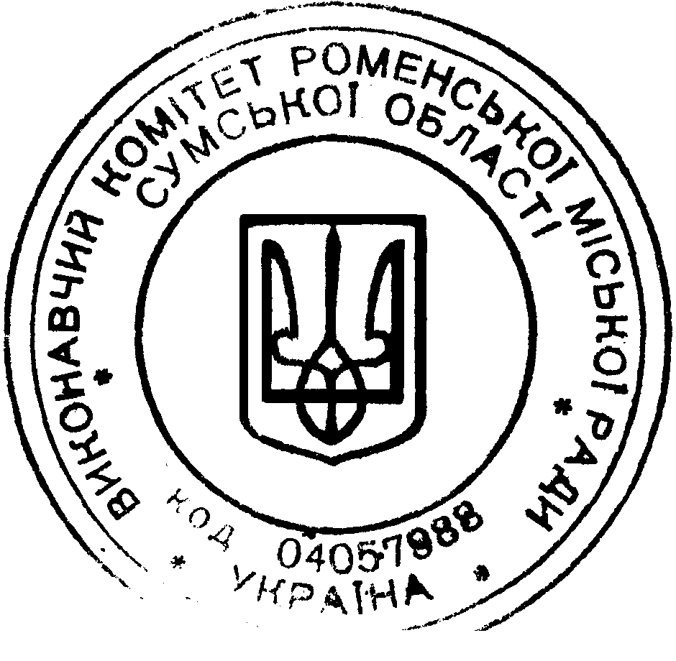
Please send photos of you municipality and any promotional materials together with this Request for twinning.

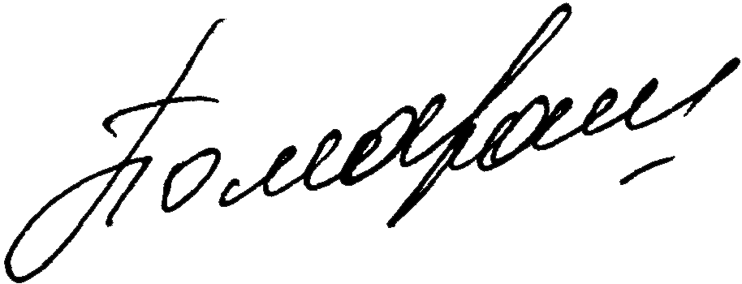
Signature and stamp:

Position: City mayor, Pomaran Pavlo Ivanovych

Date: 27.10.2009

