Search for Twinning
Municipality name: | Slobozhanska Consolidated Community
Location and geographical characteristics: | Slobozhanska Consolidated Community is located in the central part of the Dnipropetrovsk region between the autorouts M04, N31, T0404, T0405 and directly borders in the north with the regional center - the city of Dnipro (population of almost 1 million people).  The distance from the community to the capital city of Kyiv is 470 km and to the international airport "Dnepropetrovsk" is 20 km.
 | Central part of Ukraine  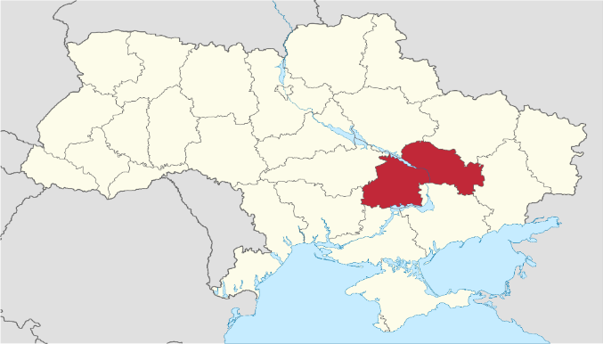 | Dnipropetrovsk region  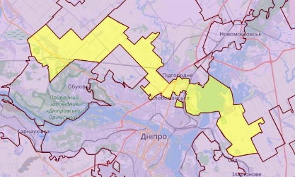
Population: | 23 480 people
Municipality characteristics: | Slobozhanska Consolidated Community was formed in 2015. The community includes 6 settlements  (1 settlement and 5 villages).  The area of the community is 282.2 square kilometers. The administrative center is the village of Slobozhanske.  Key benefits of the Consolidated Community:  - favourable location (proximity to the regional center);  - natural and recreational potential (availability of land and water resources);  - human potential, etc.
Principal economic activities in the municipality: | The total number of economic entities registered in the territory of Slobozhanska Consolidated Community is 1514, including:  industry - 156 or 10.3%  agriculture - 95 or 6.3%;  commerce - 1005 or 66.4%
Teaching facilities: | 6 general secondary education institutions with 2,896 children;  7 preschool educational institutions with 1,101 children.
Leisure facilities and activities: | 38 sports facilities, including:  1 sports and recreation complex;  ice rink, football, volleyball, basketball fields, tennis courts, workout, gyms  32 catering facilities (restaurants, cafes)
Cultural facilities and events: | 1 cinema;  9 cultural institutions (5 cultural houses and 4 libraries);  1 school of aesthetic education;  9 Orthodox churches;  1 Greek Catholic Church.
Fields of Twinning Cooperation you prefer: | Exchange of experience in the following areas:  economic development of the community;  humanitarian contacts including fields of culture, education, sports, tourism; solid waste management
Preferred countries you are looking partner town in: | Czech Republic, Republic of Poland, Hungary
Twinnings already established in your municipality: | -

